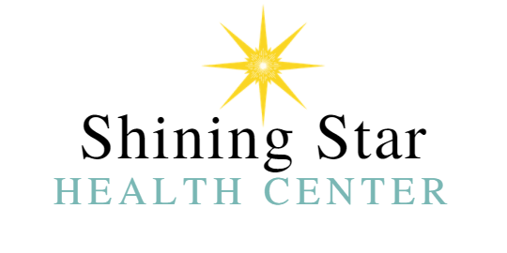

WAIVER AND RELEASE OF LIABILITY -- READ BEFORE SIGNING
In consideration of being allowed to participate in any way in the Shining Star Health Center appointments/services, its related activities, I, (__________________), the undersigned, acknowledge, appreciate, and agree that:

- The risk of injury from the activities involved in this program is significant, including the potential for psychological injury, illness, emotional loss, temporary or permanent disability, and death. Even though particular skills, equipment, and personal discipline may reduce this risk, the risk of serious injury does exist; and,

- I KNOWINGLY AND FREELY ASSUME ALL SUCH RISKS, both known and unknown, EVEN IF ARISING FROM THE NEGLIGENCE OF THE RELEASEES or others, and assume full responsibility for my participation; and,

- I willingly agree to comply with the stated and customary terms and conditions for participation. If, however, I observe any unusual significant hazard during my presence or participation, I will remove myself from participation and bring such to the attention of the Business immediately; and,

- I, for myself and on behalf of my heirs, assigns, personal representatives, and next of kin, HEREBY RELEASE, INDEMNIFY, AND HOLD HARMLESS Shining Star Health Center, their agents and/or employees, other participants, owners, and lessors of premises used for the activity ("Releasees"), concerning ANY AND ALL INJURY, DISABILITY, DEATH, or loss or damage to person, WHETHER ARISING FROM THE NEGLIGENCE OF THE RELEASEES OR OTHERWISE, to the fullest extent permitted by law.

- Shining Star provides alternative and experimental protocols which are not FDA approved. A cure for your condition is neither suggested nor implied.

I HAVE READ THIS RELEASE OF LIABILITY AND ASSUMPTION OF RISK AGREEMENT, FULLY UNDERSTAND ITS TERMS, UNDERSTAND THAT I HAVE GIVEN UP SUBSTANTIAL RIGHTS BY SIGNING IT, AND SIGN IT FREELY AND VOLUNTARILY WITHOUT ANY INDUCEMENT.
x _______________________________ DOB: Date Signed:_____________
PARTICIPANT'S SIGNATURE
FOR PARENT/LEGAL GUARDIAN OF PARTICIPANTS OF MINORITY AGE
This is to certify that I, as a parent/legal guardian with legal responsibility for this participant, do consent and agree to his/her release as provided above of all the Releasees, and, for myself, my child and our heirs, assigns, and next of kin, I release and agree to indemnify and hold harmless the Releasees from any liabilities incident to my minor child's involvement or participation in these programs as provided above, EVEN IF ARISING FROM THE NEGLIGENCE OF THE RELEASEES to the fullest extent permitted by law.

_______________________________________________ Date Signed: _____________ PARENT/LEGAL GUARDIAN SIGNATURE (print name)

Use this section if you would like to leave a comment or question for Shining Star Health Center.
____________________________________________________________________________________________________________________________________________________________________________________________________________________________________________________________________________________________________________________________________________________________________________________________________________________________________________________________________________________________________________________________________________________________________________________________________________________________________________________________________________________________________________________________________________________________________________________________________________________________________________________________________________________________________________________________________________________________________________________________________________________________________________________________________________________________________________________________________
______________________________________________________________________________
Please send this form by email to shiningstarhc@gamil.com or bring the form along with you.

